|  |  |  |
| --- | --- | --- |
| CONNECTION | SPECIAL FUNCTION | PIN |
| Batter monitor | Analogue | A0 |
| Charging monitor |  | A1 |
| Left IR |  | A2 |
| Right IR |  | A3 |
| Left LDR |  | A4 |
| Right LDR |  | A5 |
| Temperature sensor |  | A6 |
|  |  | A7 |
| Trailer angle |  | A8 |
|  |  | A9 |
|  |  | A10 |
|  |  | A11 |
|  |  | A12 |
|  |  | A13 |
|  |  | A14 |
|  |  | A15 |
|  | Serial Communication |  |
| LCD | Serial3 | 14(TX) |
|  |  | 15(RX) not needed |
| Wireless HC-11 | Serial2 | 16(TX) |
|  |  | 17(RX) |
| GPS | Serial1 | 18(TX) not needed |
|  |  | 19(RX) |
|  | PWM |  |
|  |  | 2 |
|  |  | 3 |
|  |  | 4 |
|  |  | 5 |
|  |  | 6 |
|  |  | 7 |
|  |  | 8 |
|  |  | 9 |
| Turret servo pin |  | 10 |
| Steer servo pin |  | 11 |
| Drive servo pin |  | 12 |
|  |  | 13 |
| Hall wheel sensor | DIGITAL | 22 |
|  |  | 24 |
|  |  | 26 |
|  |  | 28 |
|  |  | 30 |
|  |  | 31 |
|  |  | 32 |
|  |  | 33 |
|  |  | 34 |
|  |  | 35 |
|  |  | 36 |
|  |  | 37 |
| Led1 |  | 38 |
|  |  | 39 |
| Led2 |  | 40 |
|  |  | 41 |
| Led3 |  | 42 |
|  |  | 43 |
| Button1 |  | 44 |
|  |  | 45 |
| Button2 |  | 46 |
| TX Software serial SD card |  | 47 |
| Button3 |  | 48 |
| Ultrasonic echo |  | 49 |
| TX Software serial Bluetooth |  | 50 |
| Ultrasonic trigger |  | 51 |
| RX Software serial Bluetooth |  | 52 |
| RX Software serial SD card |  | 53 |

Compass I2C address 60

GPS Serial1 pin at 4800

Or 115200 PIKSI (#define PIKSI_GPS)

Wireless Serial2 at 1200

LCD Serial3 9600

Bluetooth module (Serial3?)

<http://www.instructables.com/id/Connect-Arduino-Uno-to-Android-via-Bluetooth/>

SD card (Serial??)

Software serial library: Only can use: RX: 10, 11, 12, 13, 14, 15, 50, 51, 52, 53, A8 (62), A9 (63), A10 (64), A11 (65), A12 (66), A13 (67), A14 (68), A15 (69).

<https://www.arduino.cc/en/Reference/SoftwareSerial>

[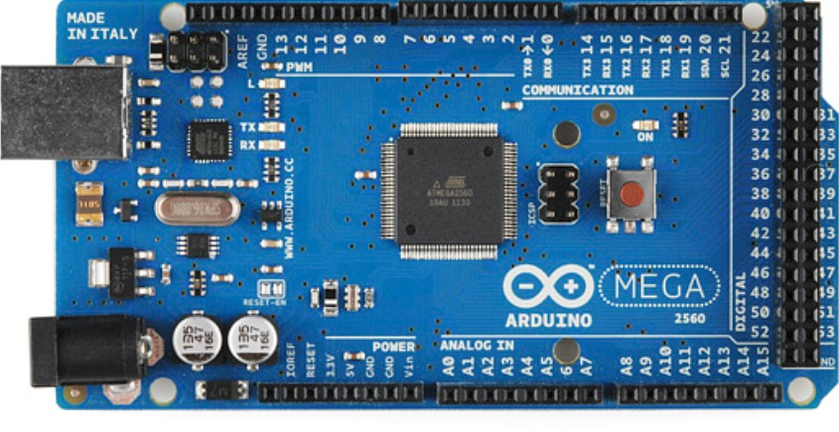](http://www.google.co.uk/url?sa=i&rct=j&q=&esrc=s&source=images&cd=&cad=rja&uact=8&ved=0ahUKEwiNn5nX5-DUAhUL1BoKHbl-CmUQjRwIBw&url=http://www.c-sharpcorner.com/UploadFile/d15fb8/gsm900-module-with-arduino-mega/&psig=AFQjCNE-D3lghnE54rW5M08YrsctkmysqQ&ust=1498748572545290)